**PRACTICAL NO 2**

Aim : Creating a Forensic Image using FTK Imager/Encase Imager

* Creating Forensic Image
* Check Integrity of Data
* Analyze Forensic Image

Software Required:FTK Imager/Encase Imager

* Creating Forensic Image
  1. Click File, and then Create Disk Image, or click the button on the tool bar.

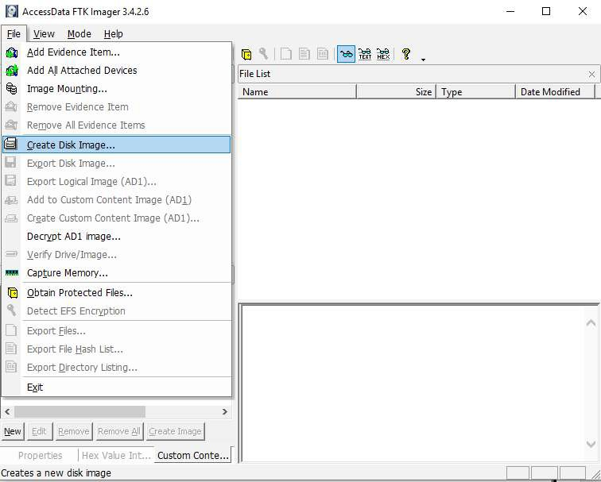

* 1. Select the source evidence type you want to make an image of and click Next.

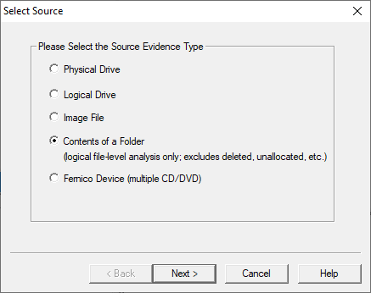

* 1. Select the source evidence file with path .

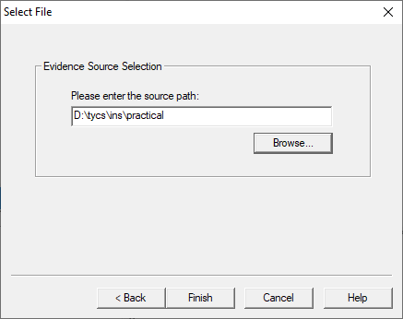

Click on “add” to add image destination

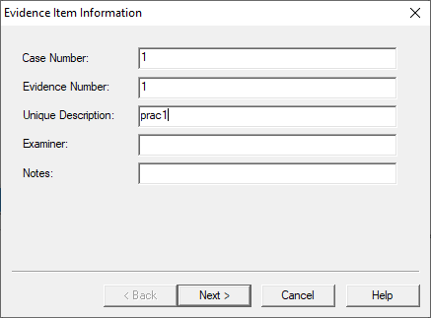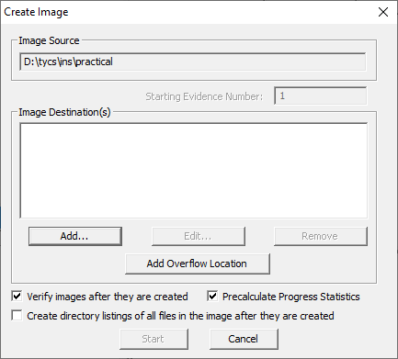

* 1. In the Image Destination Folder field, type the location path where you want to save the image file, or click **Browse** to find to the desired location.

**Note:** If the destination folder you select is on a drive that does not have sufficient free space to store the entire image file, FTK Imager prompts for a new destination folder when all available space has been used in the first location.In the Image Filename field, specify a name for the image file but do not specify a file extension.

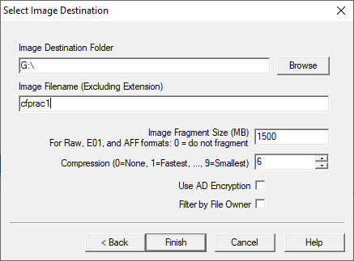

* 1. After adding the image destination path click on finish and start the image processing.

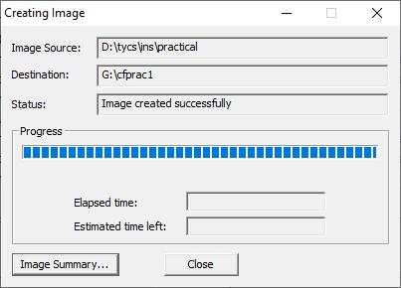

* 1. After the images are successfully created, click Image Summary to view detailed file information, including MD5 and SHA1 checksums.

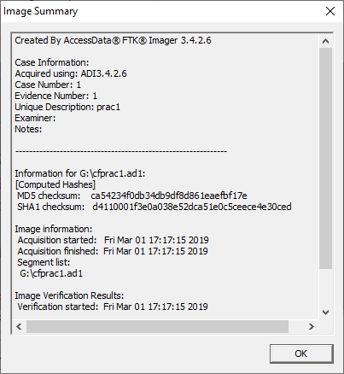

## Analyze Forensic Image:

Click on Add Evidence Item to add evidence from disk, image file or folder.

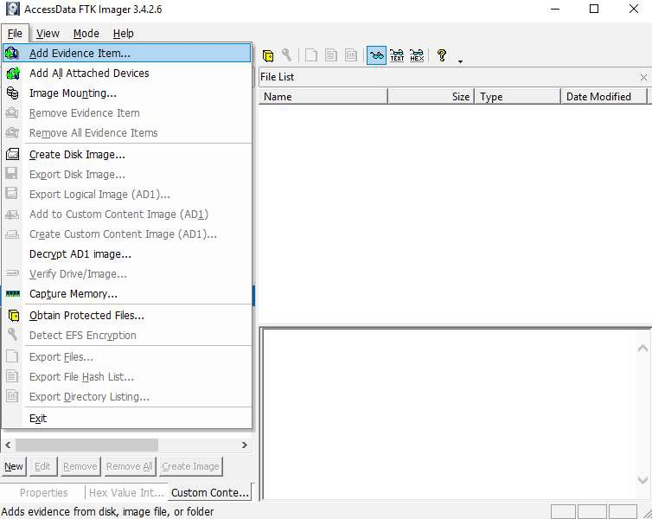

Now select the source evidence type as image file.

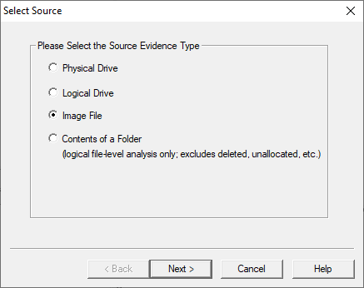

Open the created evidence image file

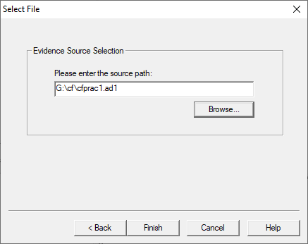

Now select Evidence Tree and analyze the image file .

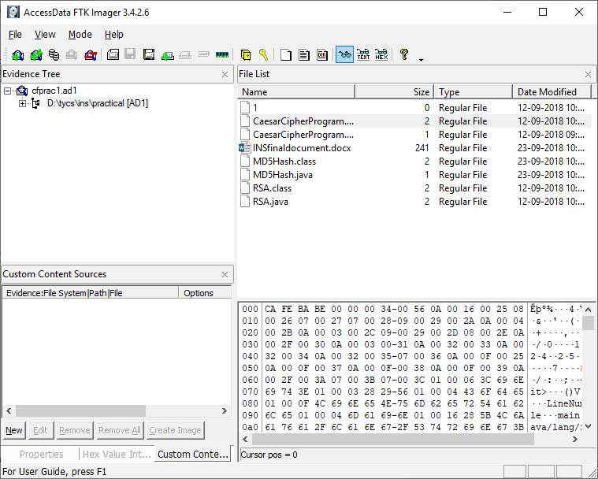

Conclusion: Thus we have to Creating a Forensic Image using FTK Imager/Encase Imager

# PRACTICAL 3

Aim: Data Acquisition using Prodiscover

* Perform data acquisition using:
* USB Write Blocker + FTK Imager

## Steps:

Step 1: First Open Prodiscover Basic and start with new case.

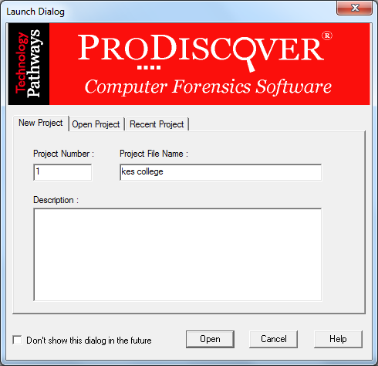

Step 2: The created project appears in left pane and select add>capture & add image.

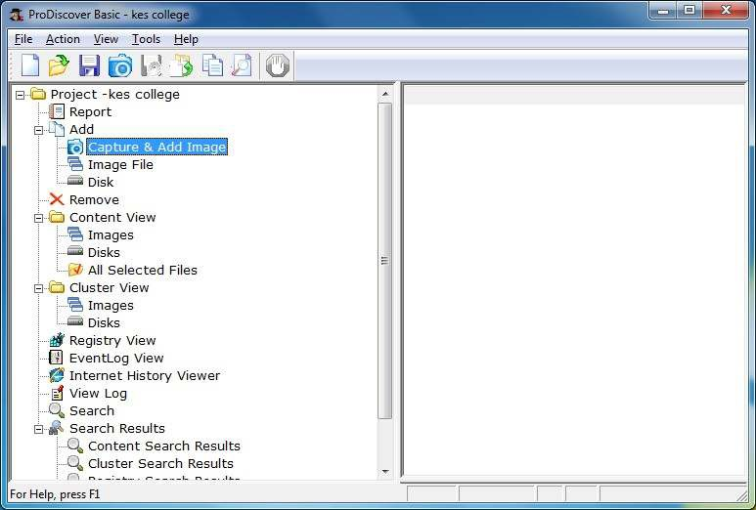

Step 3: fill the details as below. And click ok.

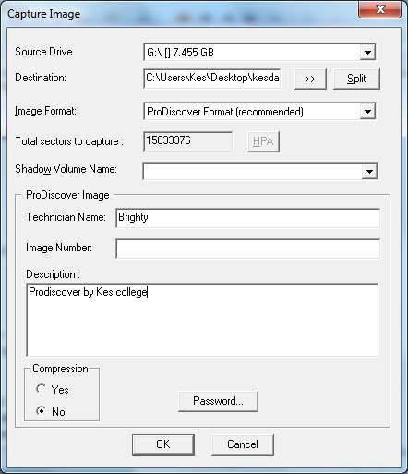

Step 4: capturing of image starts.

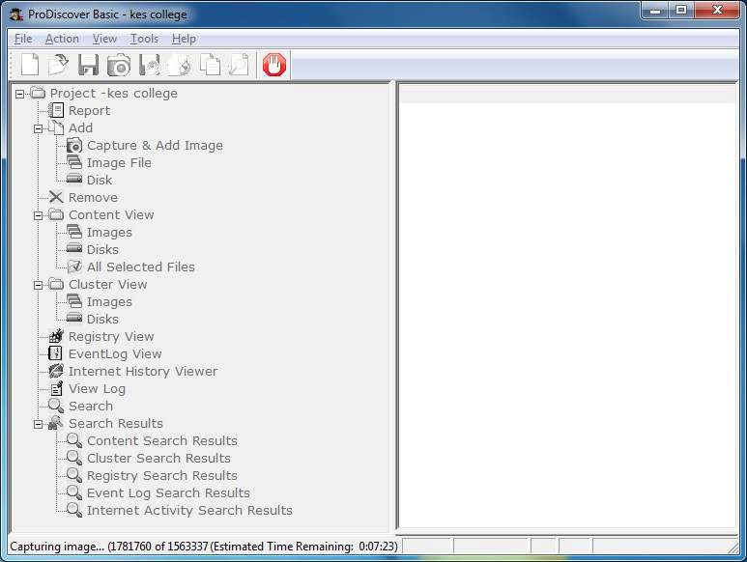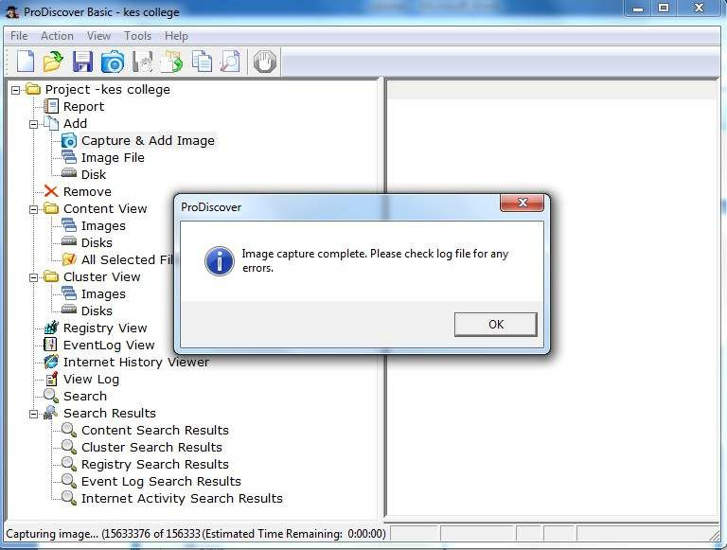

Step 5: Open the image created, go to Add > Images in left pane.

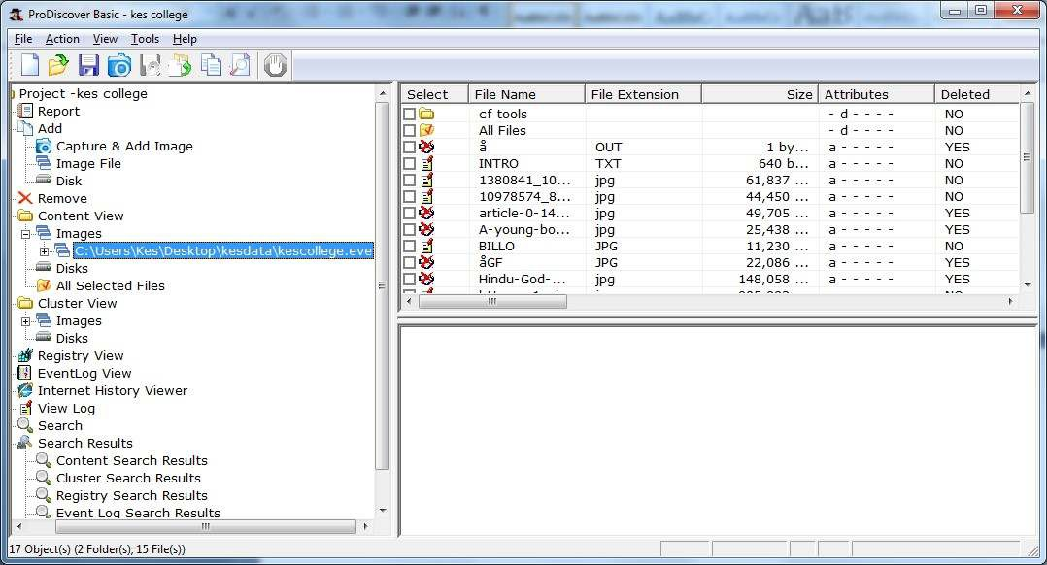

Step 6: Click on any File and type a comment.

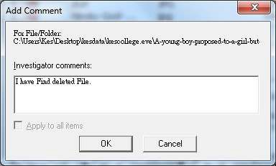

Step 7 : the cluster view is seen from the cluster view in left panel.

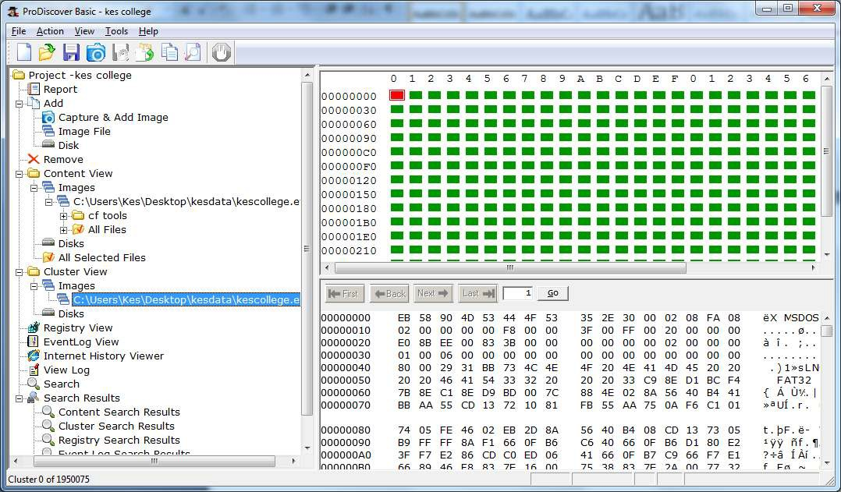

Step 8 : We can also view gallery view by Right Click.

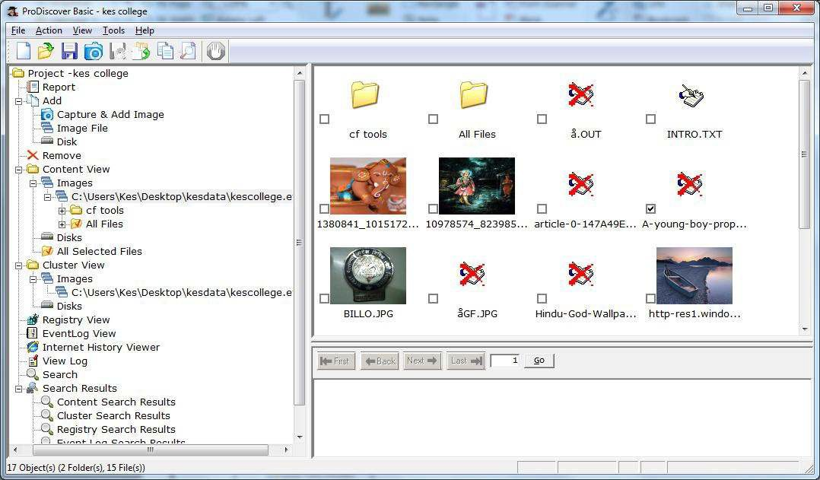

Step 9: Keyword search. Click on Search in left pane and Enter the file name to be searched in the image created.

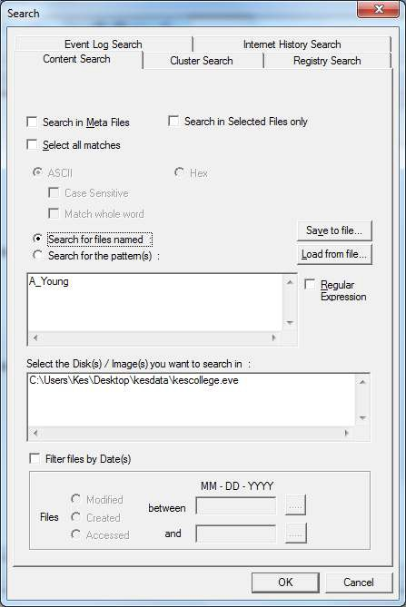

Step 10 : Output of Keyword search.

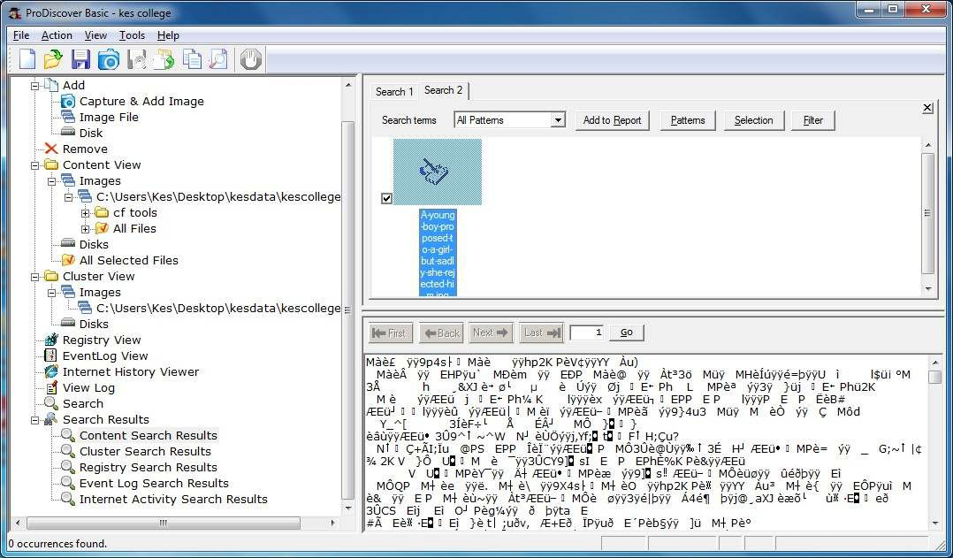

Step 11 : Click on View>Report.

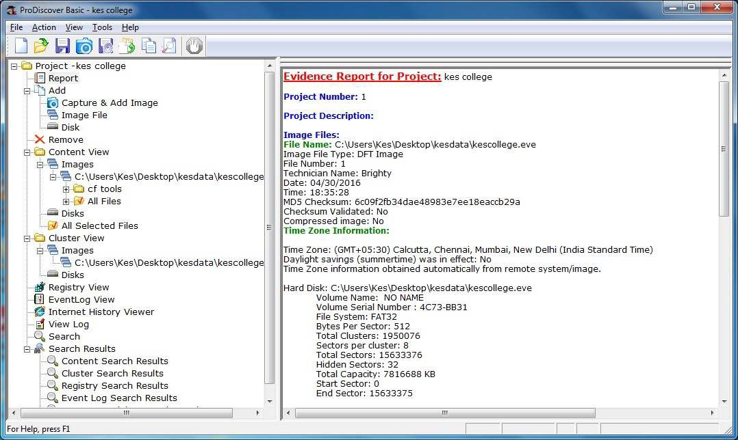

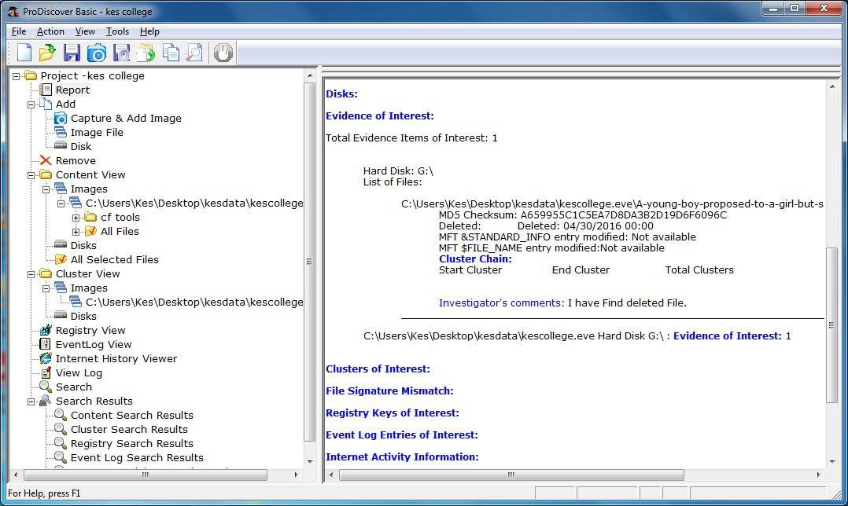

**Conclusion:Thus,we have performed the practical successfully.**